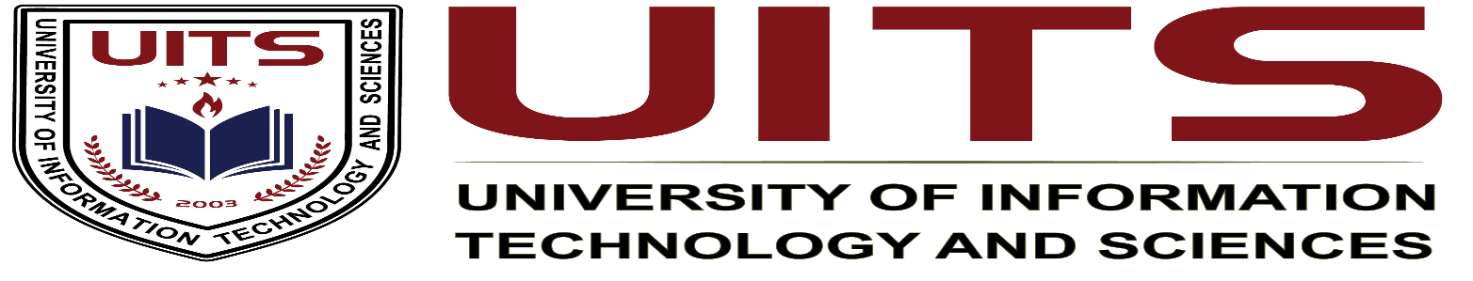lication Design

**Course Name :** Industrial Attachment

**Course Code :** CSE 420

**Student Name :** Md Shariful islam sajib sarker

**Student ID :** 2125051016

**Batch :** 50

**Section :** 7A1

**Semester :** Autumn

**Seminar Topic :** Software Freedom Day

**Keynote Speaker :** Mr. Sajedur Rahim Joarder, President of FOSS

ion :Date of Submission :

**Software Freedom Day**

**Introduction:**

The seminar titled "Software Freedom Day" was about discussing the importance of open-source software and the vision of making operating systems freely available for everyone. The seminar cover why software should be accessible and transparent to the public, systems like Linux and promoting the idea that software should serve users without hidden costs or data collection.

**Keynote speaker background:**

The speaker, Mr. Sajedur Rahim Joarder, is the President of the Free and Open Source Software (FOSS) community. He is well-regarded for his open-source principles and extensive knowledge in free software development. With years of experience promoting software freedom, He has influenced the development of several open-source projects and actively campaigns for greater transparency in software design.

**Purpose and goals of the seminar:**

* Emphasizing the benefits of making operating systems free and accessible.
* Highlighting how most commercial software have hidden costs, often compromising user privacy.
* Inspire us to support and contribute to open-source mindset.

**Key points and discussions:**

* **The philosophy of free software**: he introduced the philosophy behind free software, focusing on how an open-source operating system like Linux respects user freedom by allowing them to view, modify, and share the code.
* **Privacy concerns in proprietary software**: he also discussed how proprietary software often indirectly takes something from the users usually in the form of data collection or restrictions on usages. He highlighted the risks users face when they cannot see the underlying code, which can lead to privacy invasion or hidden costs.
* **Importance of assembly code transparency**: he emphasized the need for assembly level code to be open source so that everyone can understand and trust the software they use. He argued that proprietary code limits user freedom and creates dependencies that are difficult to escape.
* **Challenges in achieving software freedom**: he also emphasize that while free software has made progress, fully achieving software freedom remains challenging. Proprietary software dominates the market, and there are few initiatives truly committed to open-source ideals.

**New information or skills gained:**

The seminar gives a deeper understanding of the ethical and practical advantages of open source software. we learned about the importance of data privacy and how software companies exploit user data. also gained insight into the benefits of using open source operating systems like linux and why transparency in code is needed for building trustworthy software.

**Bridging the gap between academic learning and industry practices:**

This seminar revealed a significant gap between the principles of software freedom and current industry practices. Academic programs often focus on teaching proprietary software and industry standard tools that are not open source. seminar emphasized the value of open source knowledge, inspiring us to question the ethics behind software practices and motivating them to consider privacy and transparency in their projects.

**Insights for improving academic programs:**

* **Teach open source tools**: Introducing open source tools and encouraging students to contribute to open source projects could create a greater understanding of software freedom.
* **Offer courses on data privacy and ethics**: Academic institutions should include courses on data ethics, privacy concerns, and software transparency, enabling students to understand the consequences of proprietary software.
* **Support open source initiatives**: universities could collaborate with organizations like FOSS to provide resources for students interested in contributing to open source projects.

**Seminar summary:**

The Software Freedom Day seminar highlighted the need for software to be free and accessible to everyone. he shared his insights into the risks of proprietary software, which comes with hidden costs that restrict user freedom greatly.

**Final thoughts and overall significance:**

The seminar was very interesting urging participants to consider the ethical aspects of the software they use and develop. It emphasized the importance of data privacy, user control, and the need for transparency. This seminar serves as a reminder that software should empower users, not exploit them, and encourages future developers to create technology with integrity.